1. Find the transfer function for the following circuit.



Review:

For non-inverting amplifier,

Where and

Gain

1. A real diode approximately has a characteristic equation , where is the voltage across the diode and and are constants inherent to the diode specifications. . From this equation, find the relationship between output voltage and input voltage for the following configuration. (Hint: First find the current through , which is the same as , then solve for , which will be .

.





Input current:

The circuit takes logarithm of the input voltage.

1. A charge amplifier is designed for a piezoelectric sensor. Calculate the dc offset voltage if a 100 M bypass resistor is used in the feedback loop assuming:
2. The operational amplifier is an LM741, with input bias current of 500 nA.
3. The operational amplifier is an OP07 with input bias current of 4 nA.
4. The operational amplifier is an LF356 jfet with input bias current of 30 pA.

Comment on whether or not any of these offsets could pose a problem with the overall circuit function.

First case is problematic, as the bias current will saturate the circuit. Case b will have an impact but is not problematic. Case c is negligible.

1. The circuit below does a weighted sum on the three inputs, , , and .

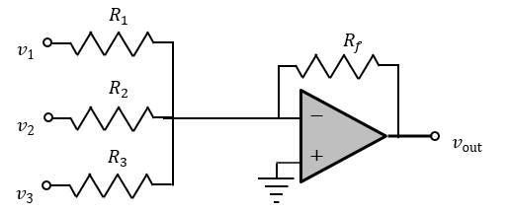

1. Show that the output of the circuit is

Review:

1. Show that if is replaced by a capacitor (), the output voltage is

This element is a summing integrator, which is useful in feedback control and the design of complex transfer functions.

Review:

1. It is also possible to feed the output of the circuit back as one of the voltages in the sum. Sketch a system containing a single operational amplifier whose output voltage is given by

Or, equivalently, that solves the differential equation

**Note:** This may seem like a random question, but we will revisit it when we do feedback control in BIEN 403.

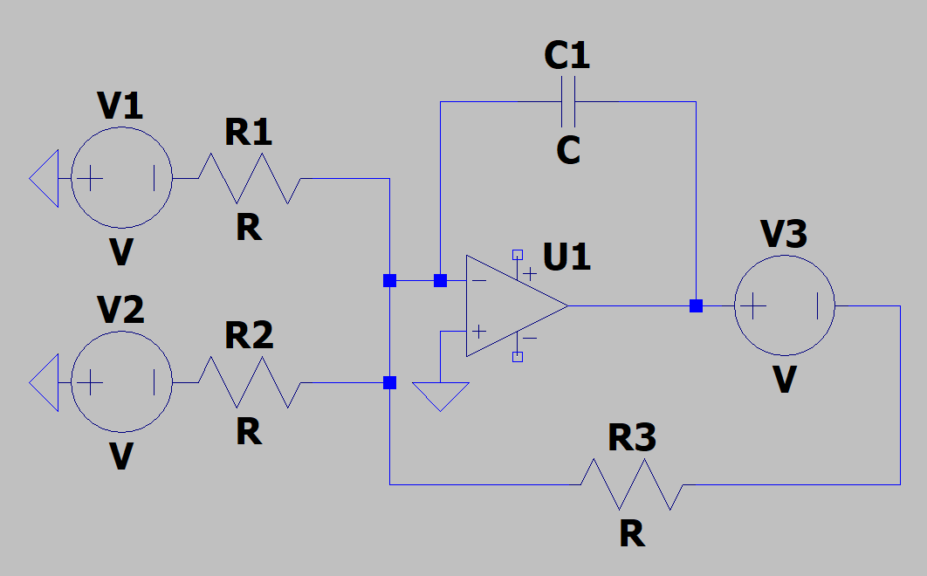

1. (Calculation of magnitude and phase) For the following circuit

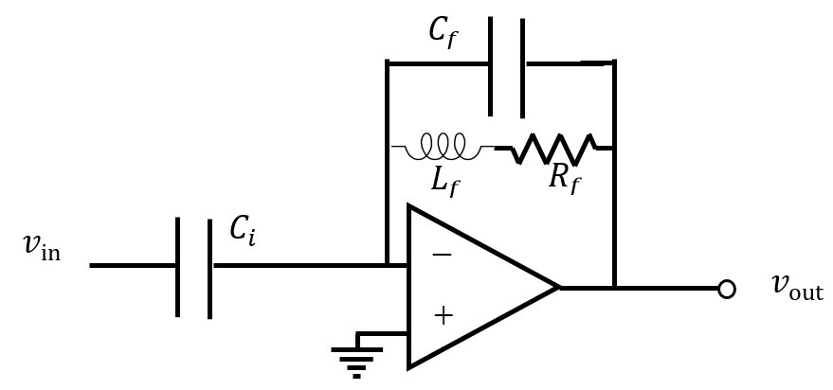

1. Find the transfer function.

Review:

1. Does the circuit have pathways for the bias currents?

Review: yes, the positive input goes to ground, the negative input has a feedback loop from .

1. What is the DC gain of the circuit?

Review:

If , gain is 0.

1. What is an expression for the magnitude of the transfer function?

Review:

1. What is an expression for the phase of the transfer function.

Review:

1. Use Excel to plot the magnitude and phase of this transfer function as a function of frequency (i.e. a Bode plot). Use the following parameter values.

Magnitude

Phase

**Graduate Content**

**Problem B:** A piezoelectric sensor plus cable has a 1 nF capacitance and 10 G resistance. The charge generated by the crystal is , where is the sensitivity and is the change in height of the crystal. The crystal is therefore modeled as a current source, where . Assume that C/m. A voltage amplifier for this sensor, with a gain of 10, is shown in Figure 1.

Sensitivity can also be given in units of voltage per displacement. If the sensitivity is given as 5 V/m, it means that the output voltage will be , which means that the charge generated is = , where is in .



Figure : Voltage amplifier for a piezoelectric sensor.

1. Assume, initially, that both and the input impedance of the operational amplifier are infinite. What voltage will appear across the capacitor if the piezoelectric crystal is instantaneously compressed by 200 m, and what value of will this charge cause?
2. We will show later that the input resistance of the non-inverting amplifier is , where is the operational amplifier gain, is the operational amplifier input resistance, and is the amplifier gain. This value can be much larger than . For example, if a FET-input operational amplifier is used, will be about . With a modest value of , and a gain of 10, the input resistance becomes at least . If the piezoelectric crystal is displaced by an amount that causes a charge on the capacitor of 1 (which subsequently leaks out through ), plot the capacitor voltage as a function of time.
3. For the same system described in Part 2 (amplifier resistance ), plot the frequency response of as a function of .
4. A noise source causes a displacement amplitude of 1 at 1 kHz. You are not concerned about the signal itself, but you need to ensure that it does not cause the amplifier to go into saturation (i.e. the signal must not cause the output voltage of the amplifier to exceed Volts). You therefore modify the system with a low-pass filter, as shown in Figure 2.



Figure 2: Voltage amplifier modified with a low pass filter to prevent saturation by an 1 kHz signal.

What value must the time constant, have if the 1 kHz noise is to generate an output signal no more than 1/3rd the saturation voltage?

1. How low must the bias current be to prevent the bias current from sending the amplifier into saturation.
2. An alternative strategy to prevent the bias current from causing saturation is to compensate for the increased voltage at the positive terminal with a resistor leading to the negative input, as shown in Figure 3. The ideal value for is , the sensor leakage resistance, but some error is likely to occur in balancing the two resistances. Show that if is different from by 10%, the output voltage caused by the bias current is a factor of 10 less than the value it would have if were absent.



Figure 3: Amplifier modified to compensate for bias current.

Assignment 8a on Power Spectra

This set of exercises illustrates how several theoretical results from Fourier analysis translate to practical data process.

The Matlab m file pspect.m calculates the power spectrum for the input signal. The spectrum is properly scaled so that the frequencies are correct and the power in the spectrum integrates to the power in the signal according to:

Use this routine to calculate the power spectrum in the following exercises. Please upload all answers and plots in a single Word file. (A handy way to copy the plots into a Word file is to use the snip function of Windows 7 or Windows Vista). If you are running with an earlier version of Windows, you can use the Matlab command “saveas” to save a plot as a jpg file. If you type:

>> h = plot(t,x);

>> saveas(h,’Plot of x.jpg’);

Then the plot will be saved as “Plot of x.jpg.” (If you use this approach, you will need to make slight modifications to pspect so that it saves the plots).

# Meaning of an Ensemble Averaged Spectrum

1. Generate a series of 25,600 random numbers with the Matlab rand function. I.e., calculate:

>> x = rand(1,25600) – 0.5;

>> dt = 0.001;

>> npts = 256;

And calculate the power spectrum with:

>> [p, farray] = pspect(x,dt,npts)

Explain the difference between the averaged spectrum and the individual spectrum

# Moving Average as a Filter

1. Apply the moving average filter to the signal and then calculate the power spectrum again. The moving average filter is defined as:

which is a discrete version of the convolution integral. To apply this filter, first create the coefficients. For example, if the filter window is rectangular and of length , the coefficients are:

>> C = [1 1 1 1 1 1 1 1 1 1];

The filter can then be applied with:

>> s = filter(C,1,x);

Explain the difference between the filtered signal and the unfiltered signal. Also explain the difference between the ensemble spectrum of the filtered signal and the ensembled spectrum of the unfiltered signal. Finally, explain the difference between the ensemble spectrum of the the filtered signal and the individual spectrum of the filtered signal.

# Relationship between the Window Function and the Power Spectrum

1. Find the mathematical description of the magnitude-squared of the Fourier transform of the rectangle (it will have the form of the sinc function). Plot this function on top of the power spectrum of the ensemble spectrum calculated in Exercise 2. Explain the similarities and differences.

# Non-Uniform Weighting in the Moving Average

1. Repeat Exercises 3 and 4 with a Hanning window instead of a rectangular window. You can generate a Hanning window of length 10 in Matlab with:

>> win = hanning(10);

The equation for the Hanning window of length 10 is:

Where ranges from to in steps of 2. Use this relationship to determine the Fourier transform of the window, and compare the power spectrum of the window to the ensemble power spectrum of the windowed random signal.

# Derivative as a Filter

1. The derivative of a function is approximated by:

Therefore, the following filter approximates the derivative:

>> deriv = filter([-1 1],dt,x);

Apply this function to the random sequence x. Explain the appearance of the ensembled spectrum. (Hint: Think first about the Fourier transform of the derivative of a function, where:

In addition, think about the square of the Fourier transform of . Is the spectrum of the derivative in any way related to the spectrum of the Hanning window?)